THIS IS A CERTIFICATE TO TESTIFY THAT THE FOLLOWING GROUP OF STUDENTS AND ROLL NUMBER PARTICIPATED IN THIS PROJECT:

**Student 1397551 UZAKU MARVELLOUS**

**Student 1393725 LAWAL MUBARAK**

**Student 1717223 OLUWAFUNMILOLA MICHELLE**

**Student 1416930 KUTI TOBI**

**Student 1416961 SHITTA-BEY MUNEERAH**

**Student 1421553 NDUKU TARE**

**Student 1 AKINDURO CLINTON**

The E-Project of an ALBERTO CLOCKS company website documentation.



Adeola Odeku Street, Near Eko hotel, Alhaji Masha Road, Victoria island ,Lagos.Tel:01-3428057,01-7737745.

GGY

Table of Contents

* Introduction
* Project Plan
* Problem definition
* Source Code
* Cascading Stylesheet Code
* Screenshot (Website based)
* Acknowledegement

INTRODUCTION

The basic aim of this Project is to design suitable, reliable and scalable website for our AlberTo Watch Company. The implementation of this project is to focus on the design of a Watch and Clock sales website using our knowledge of HTML, CSS and JavaScript. This project was designed using BRACKETS.

PROBLEM DEFINITION

Over the years people have found ways in checking time easier using more of their digital devices.

Our aim is to design a Watch and Clocks sales website that can give people easier accessibility to our watches all around the world. They give clients better convenience when checking the time compared to digital devices. We want to provide clients with better access to high quality and cost effective products. We also carry a wide selection of watches such as Apple, Hublot , Citizen, Rolex and more.

PROJECT PLAN

The name of the website is called Alberto Clock, it’s the website sales Company of the same name. The website displays detailed information about the company.

The website is designed using BRACKET and VScode text editors. It consists of the Home page, About us page, Contact Us, products and services rendered. ***HOME PAGE***: The home page shows a variety of latest Watches/Clocks which tells various products are being sold.

The home page design includes a header which contains the company’s name and logo. Also included in the header is the navigation bar, which links the home page to the other pages in the website. The other pages include, Shop, Services, About Us, Contact Us and Gallery as well as a link to the home page. A visitor counter that updates each time the page is opened an is initialized to 1. A footer displaying the current date and time, with a site map.

***ABOUT US***: Also included in the about us page is a well detailed description about the company, our principles, goals and visions for ourselves and our clients.

***Shop:*** Under shop consists of brands, style and luxury which have other sub-categories. The shop category shows pictures of the products of different brands and varied prices. It shows the company has every clients preferences and needs as well.

***Service***: Services is mostly based on repairs of clients watches.

***Gallery:***  Pictures of a variety watches so clients can pick any of their choices.

***CONTACT US:*** The contact us section features include an Address, phone and email section within the page.

**Hardware** **/** **software** **requirement:**

**Software:**

Technologies to be used:

- Frontend: HTML5, CSS, Bootstrap, JavaScript, jQuery, AngularJS, XML

- Data Store: JSON files or TXT files

Other Requirements:

- Operating Portal: Windows

- Browsers: Edge, Chrome, Mozilla Firefox, Safari

**Hardware:**

- Intel Core i3/i5 Processor or higher

- 8 GB RAM or above

- Color SVGA

- 500 GB Hard Disk space

- Mouse

- Keyboard

|  |
| --- |
| **Architecture** **and** **design** **of** **the** **project** |

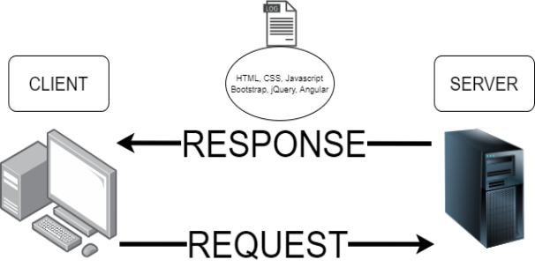

|  |
| --- |
| Screen Shots |

**I.** **Index**

|  |  |  |  |  |  |  |  |
| --- | --- | --- | --- | --- | --- | --- | --- |
| HOME | ABOUT | SERVICE | SHOP |  | LOGO | VISIT COUNT | CART |
| NEW COLLECTION | | | | | | | |
| OUR BEST SELLERS | | | | | | | |
| CONTACT | | | | | | | |
| EMAIL | | CONTINUOUS SCROLLING TICKER  CONTACT LINKS | | | | MAPS | |

**From**

**To**

: When you open Index.html, homepage will be auto load at first.

: Sections of homepage and history, appraisal, shop, repair, etc.

**From**

**To**

: About section from Index.

: Bring you to our historical page.

**III.** **Shop**

|  |  |  |  |
| --- | --- | --- | --- |
| HEADER | | | |
| SORT | | SEARCH | |
| PRODUCT 1 | PRODUCT 2 | PRODUCT 3 | SIDE BAR |
| PRODUCT 4 | PRODUCT 5 | PRODUCT 6 |
| PRODUCT 7 | PRODUCT 8 | PRODUCT (…) |

**Description** : This is shop page, it’s used to access shopping screen, have a quick research about all types of watch, we can do search on brands, names, price or features of watch in this page to filter the watch that you want.

**From** : Shop.html will be run by clicking “Shop” on Index.html.

**To** : Bring you to see the whole detail of a watch, which is called Product.html.

**IV.** **Product**

|  |  |  |  |
| --- | --- | --- | --- |
| < | PICTURE | > | NAME |
| PRICE |
| MODEL |
| FEATURES |
| SMALL PICTURES | | | DESCRIBING |
| … |

**Description** : This is Product page, which is used to show the details of a watch as well as the whole looks of the watch.

*ALBERTO CLOCKS SOURCE CODES

HTML SOURCE CODES

<!DOCTYPE html>

<html lang="en">

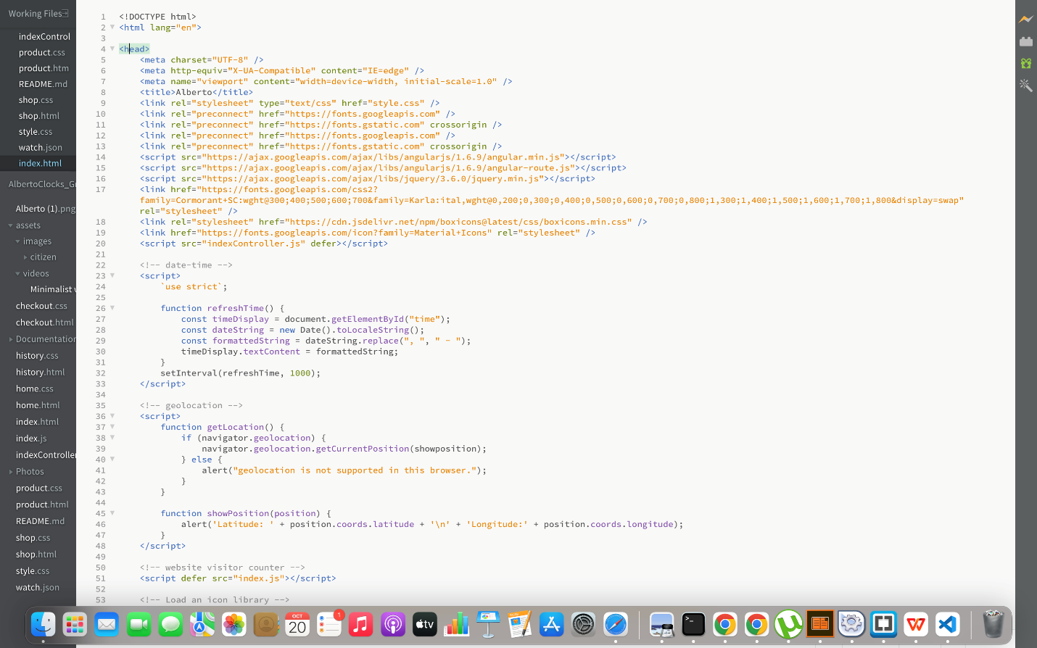

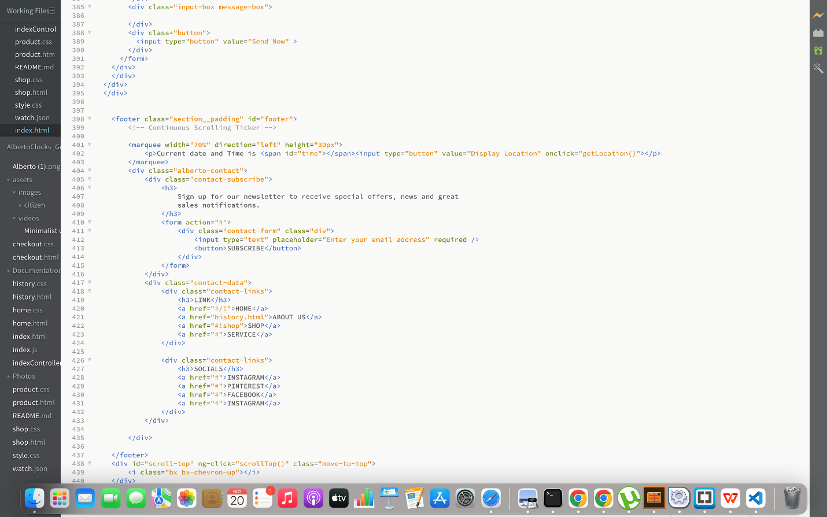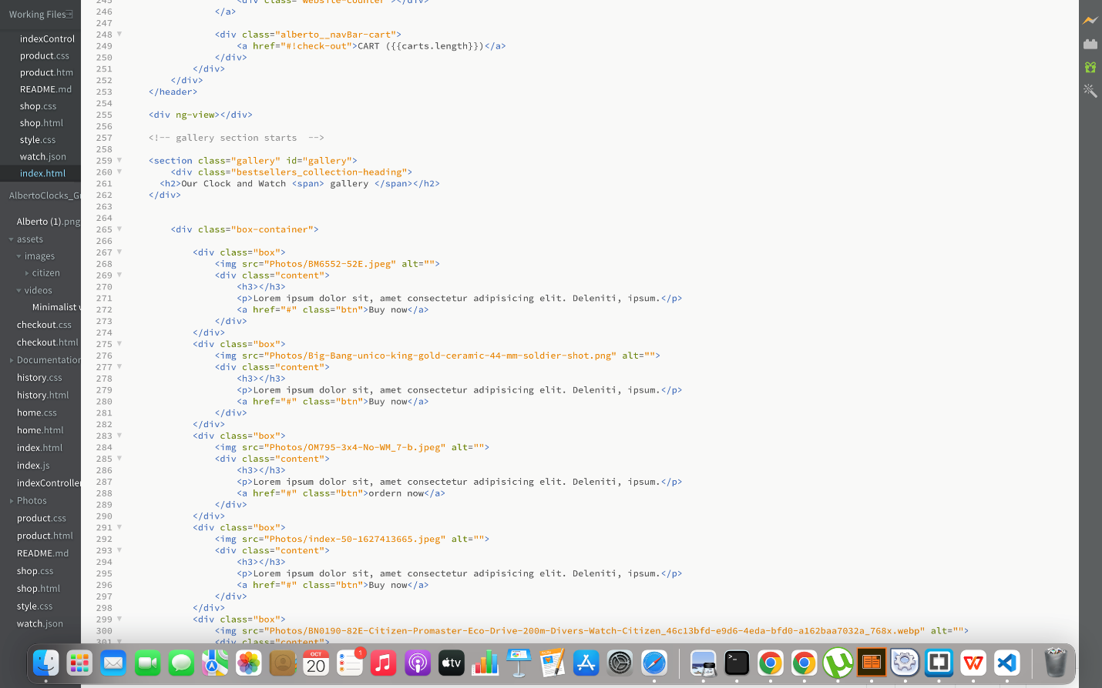



*Cascading stylesheet codes

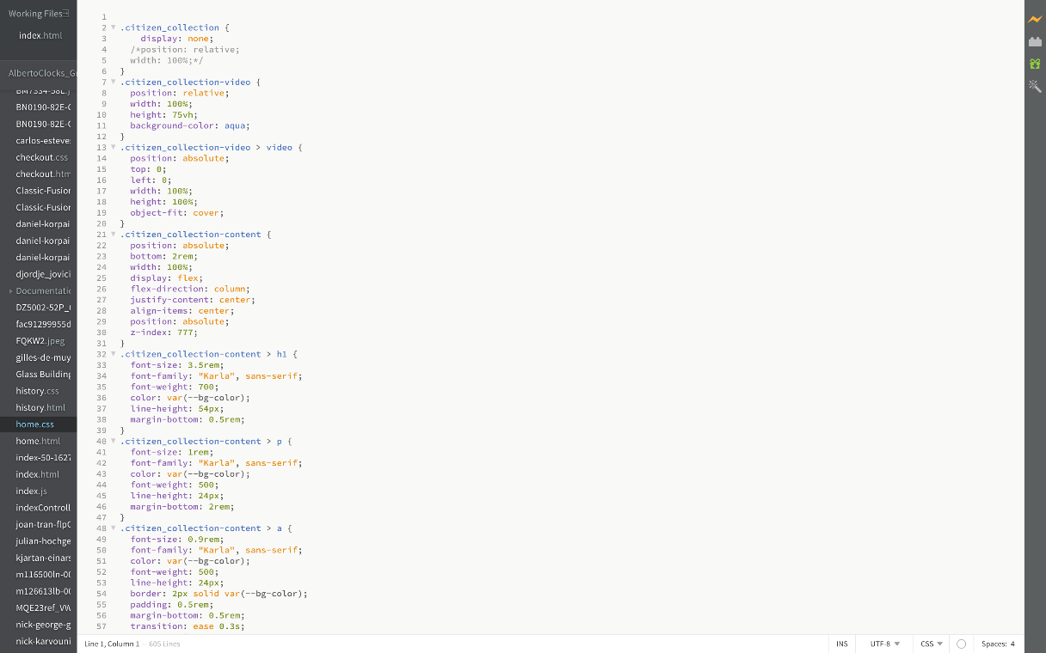

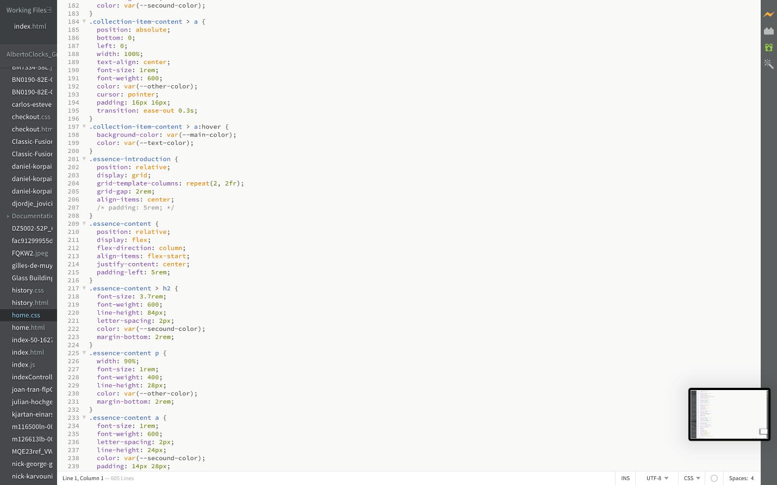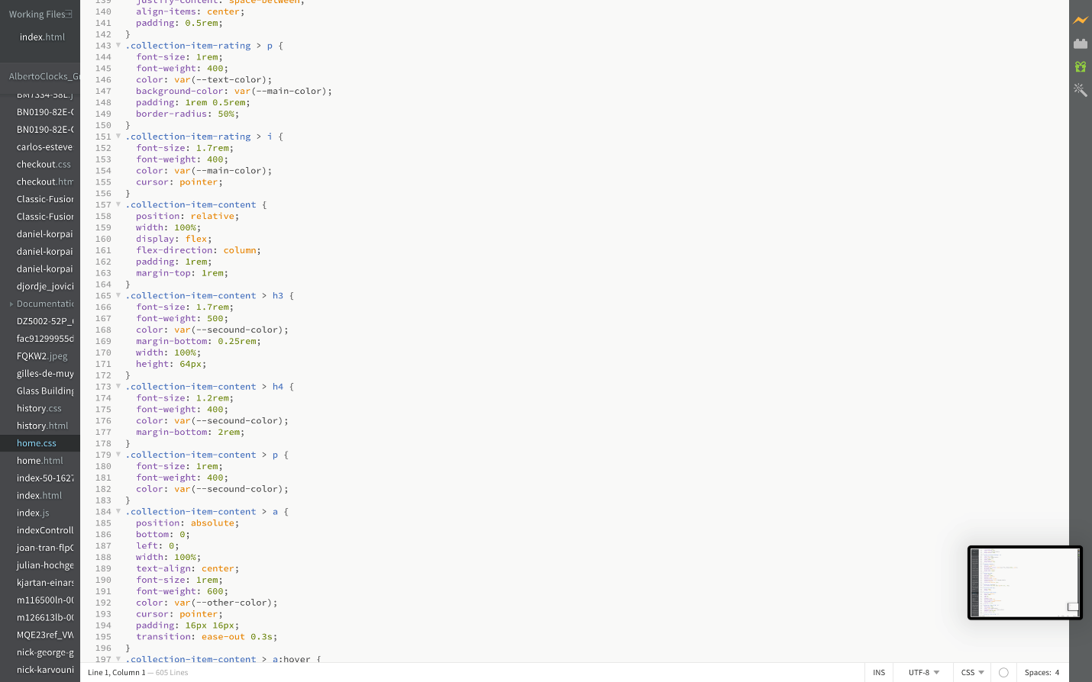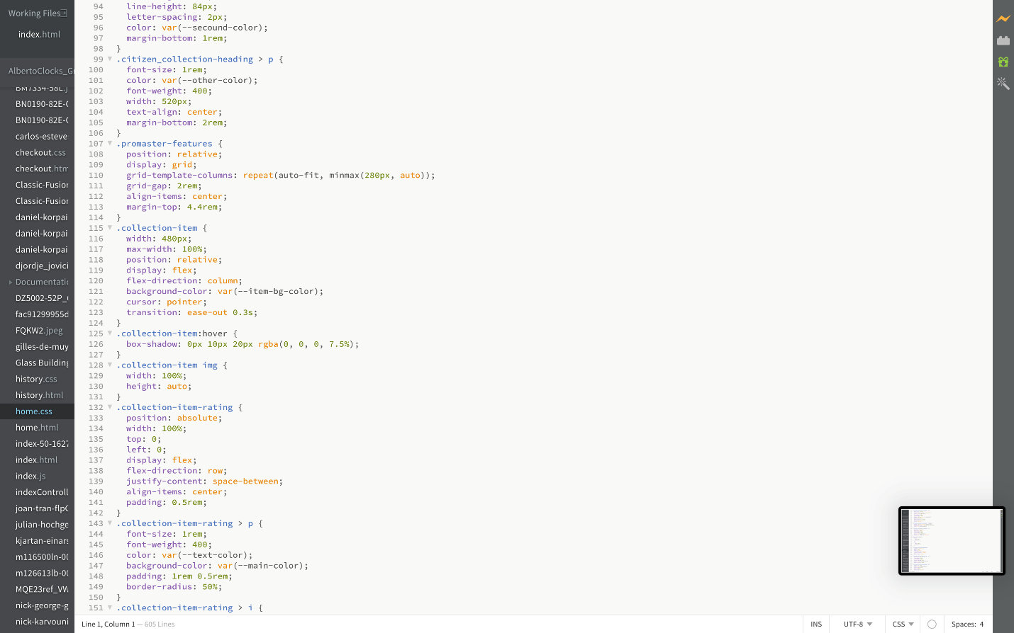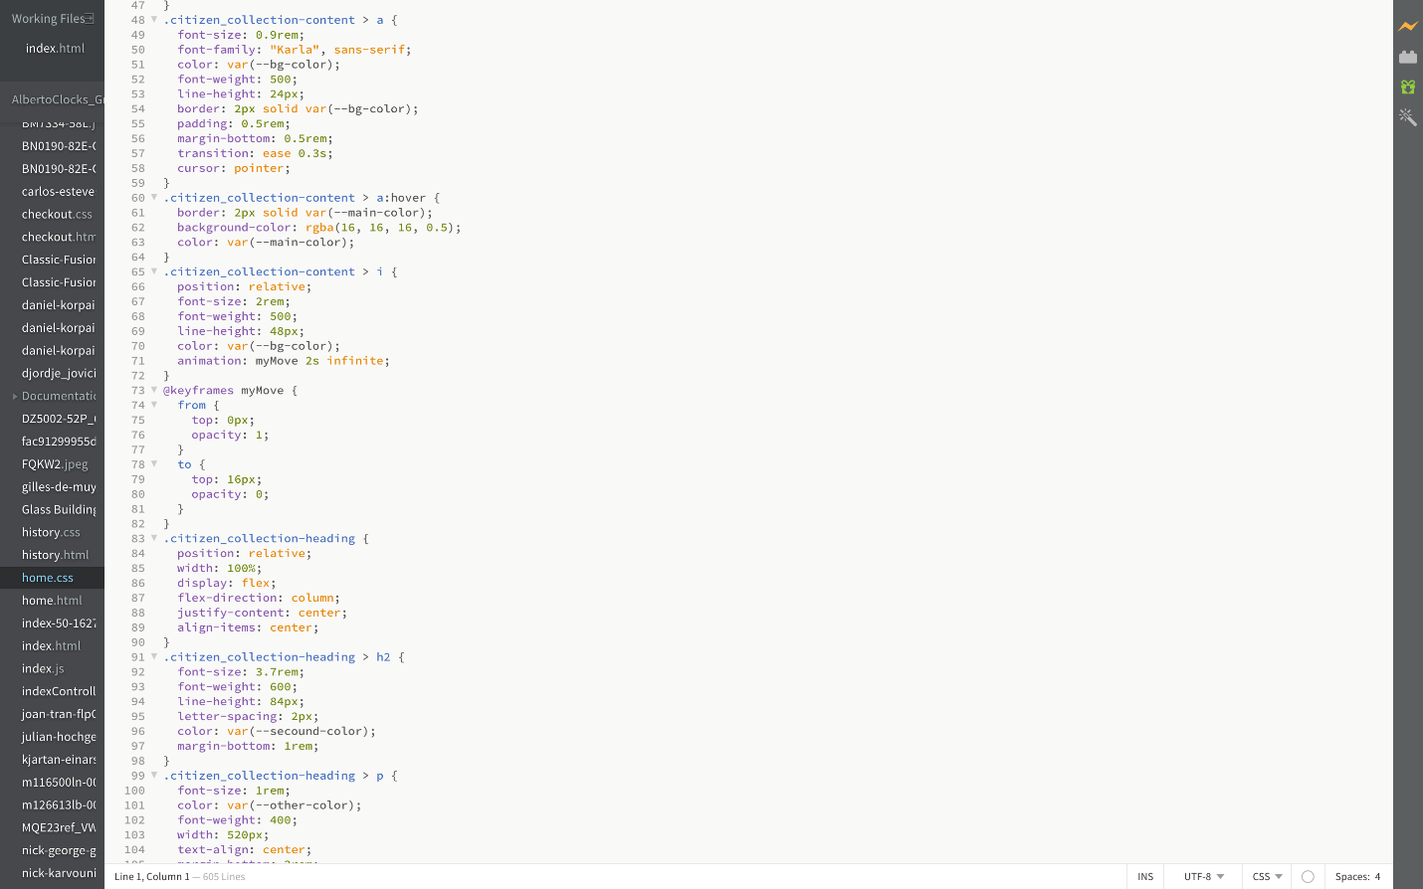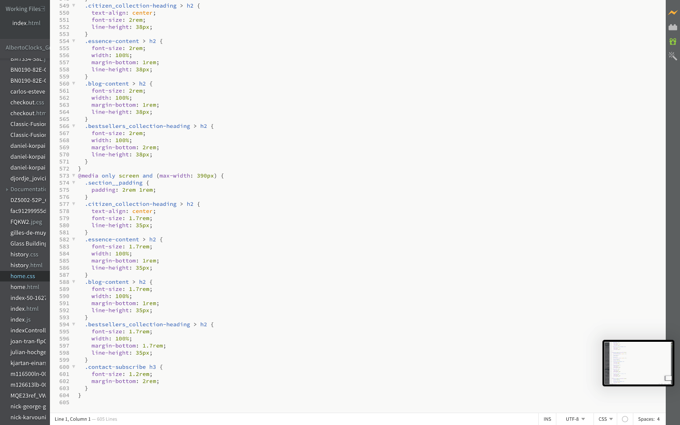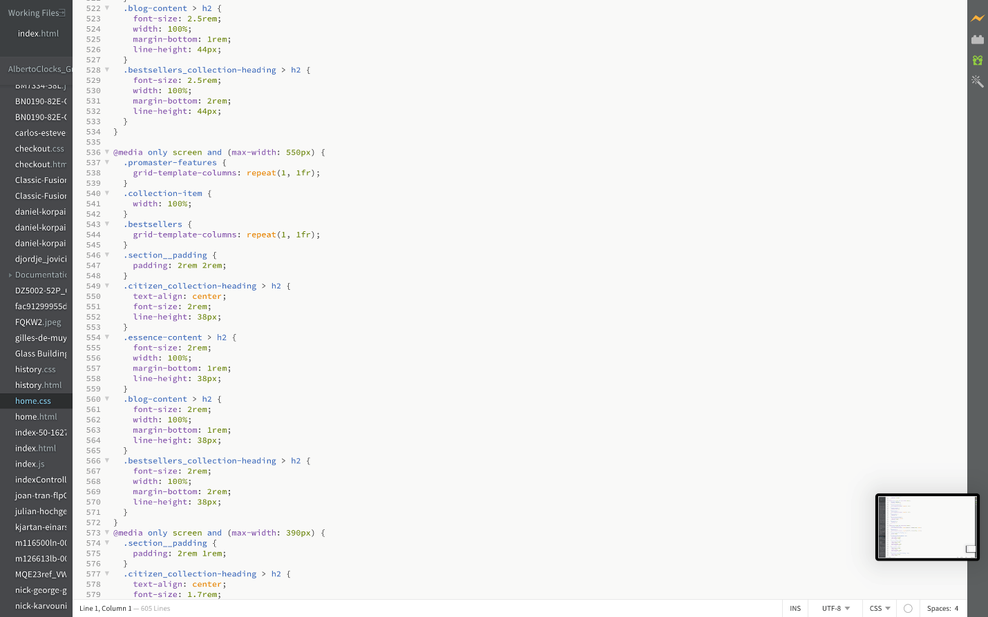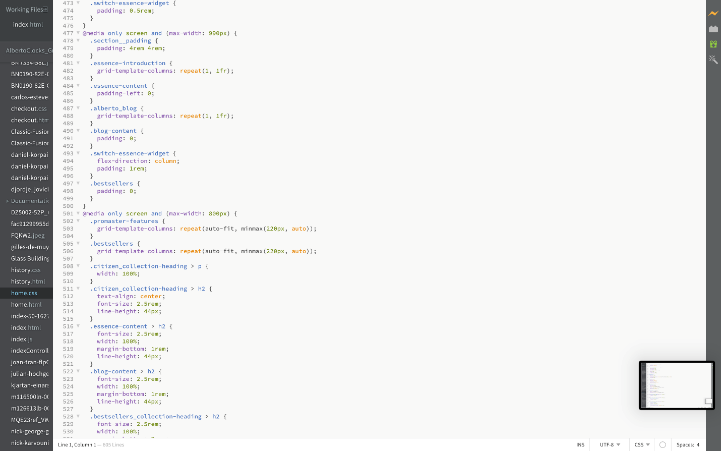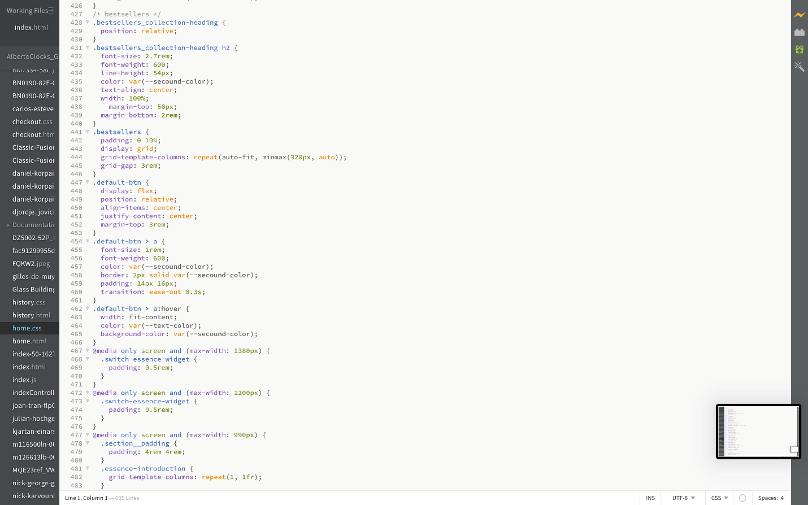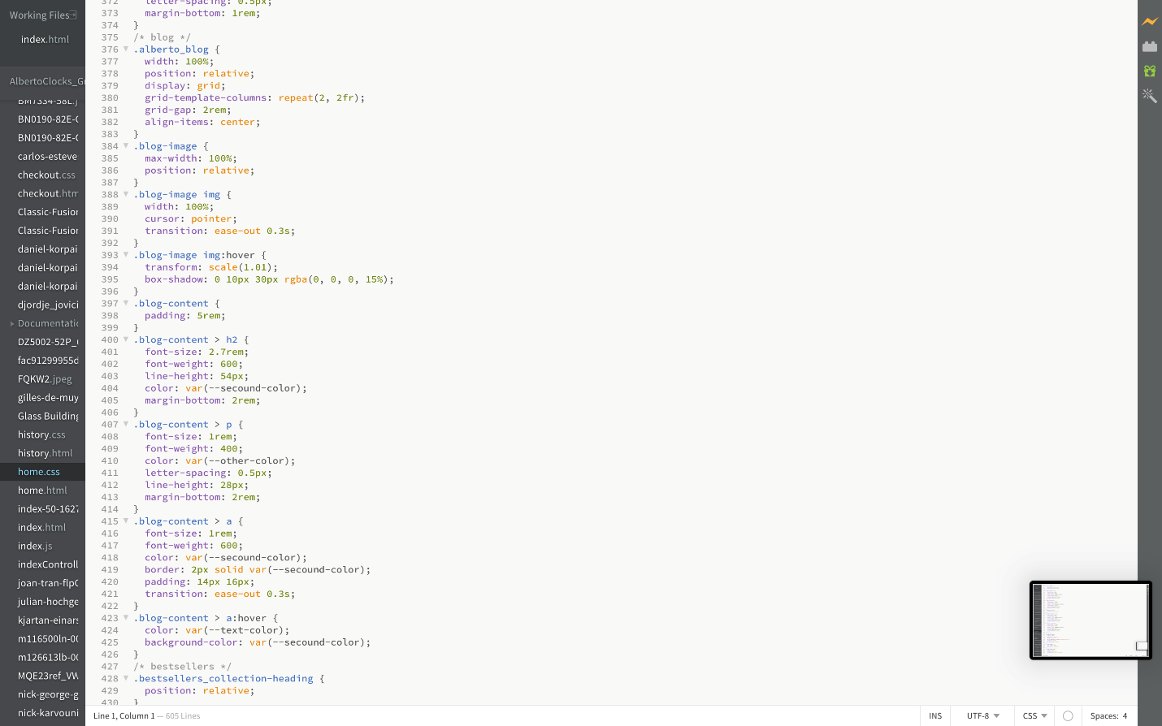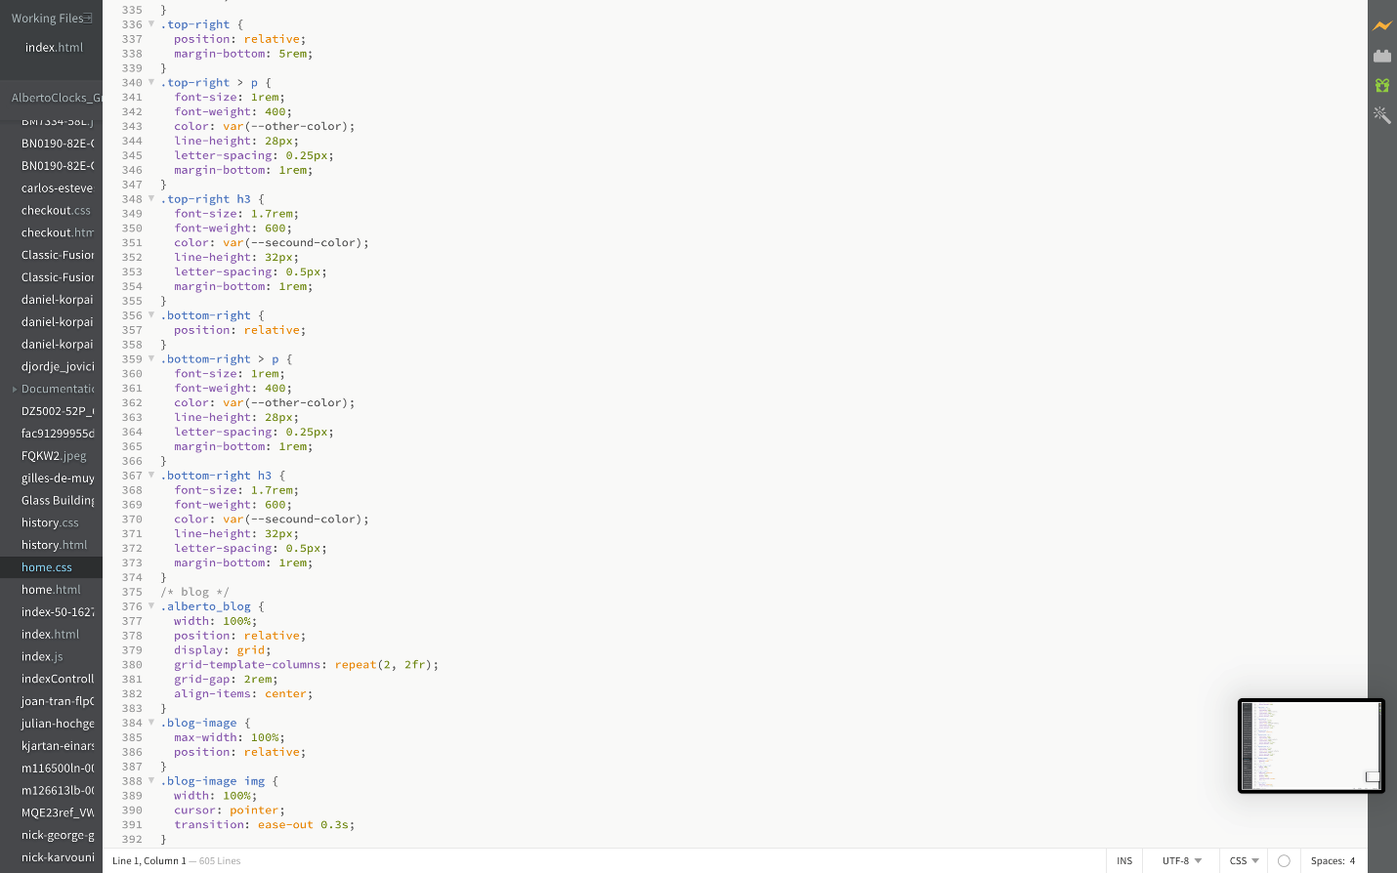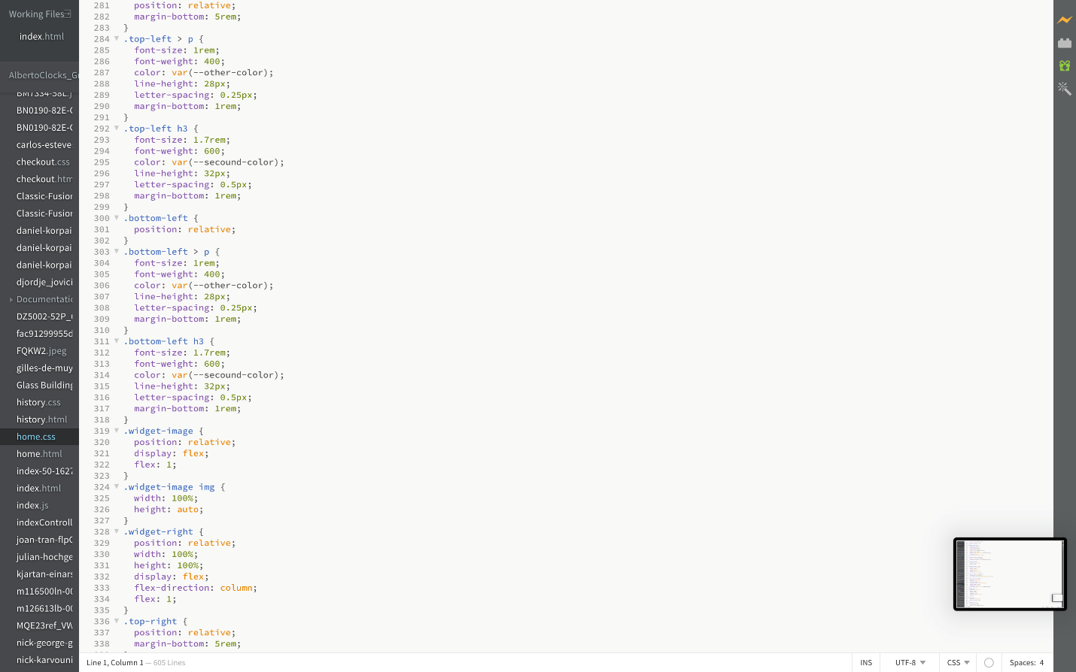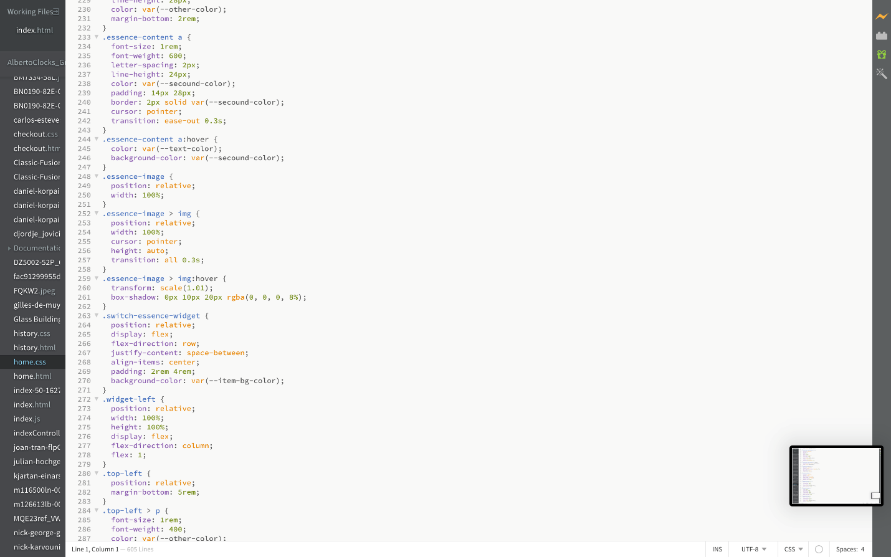

SCREENSHOTS

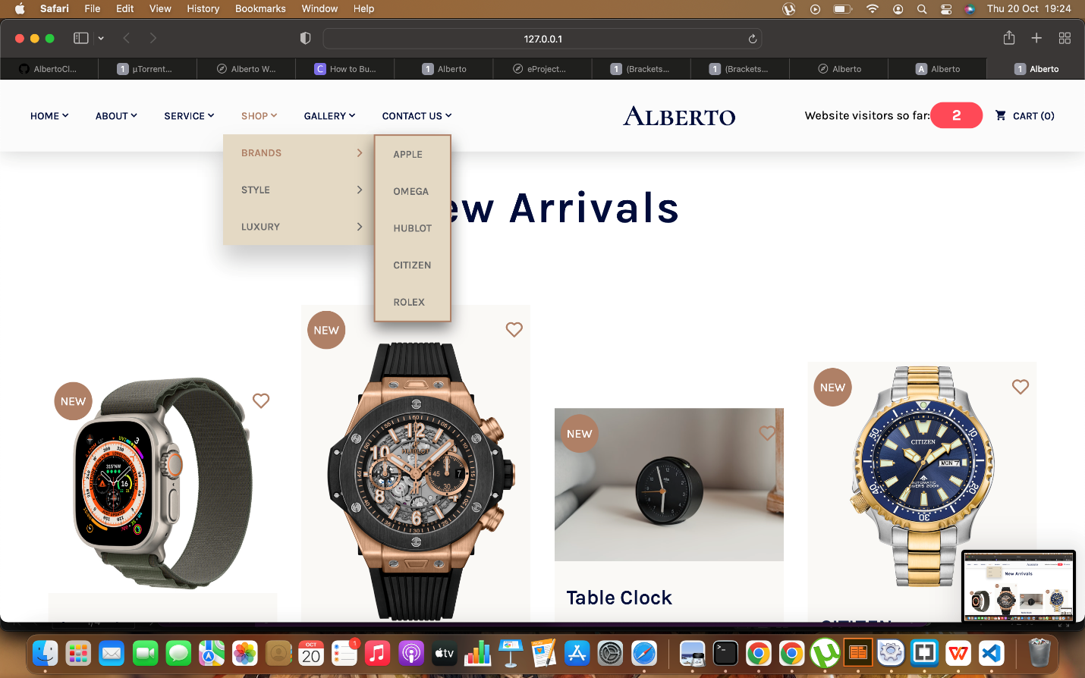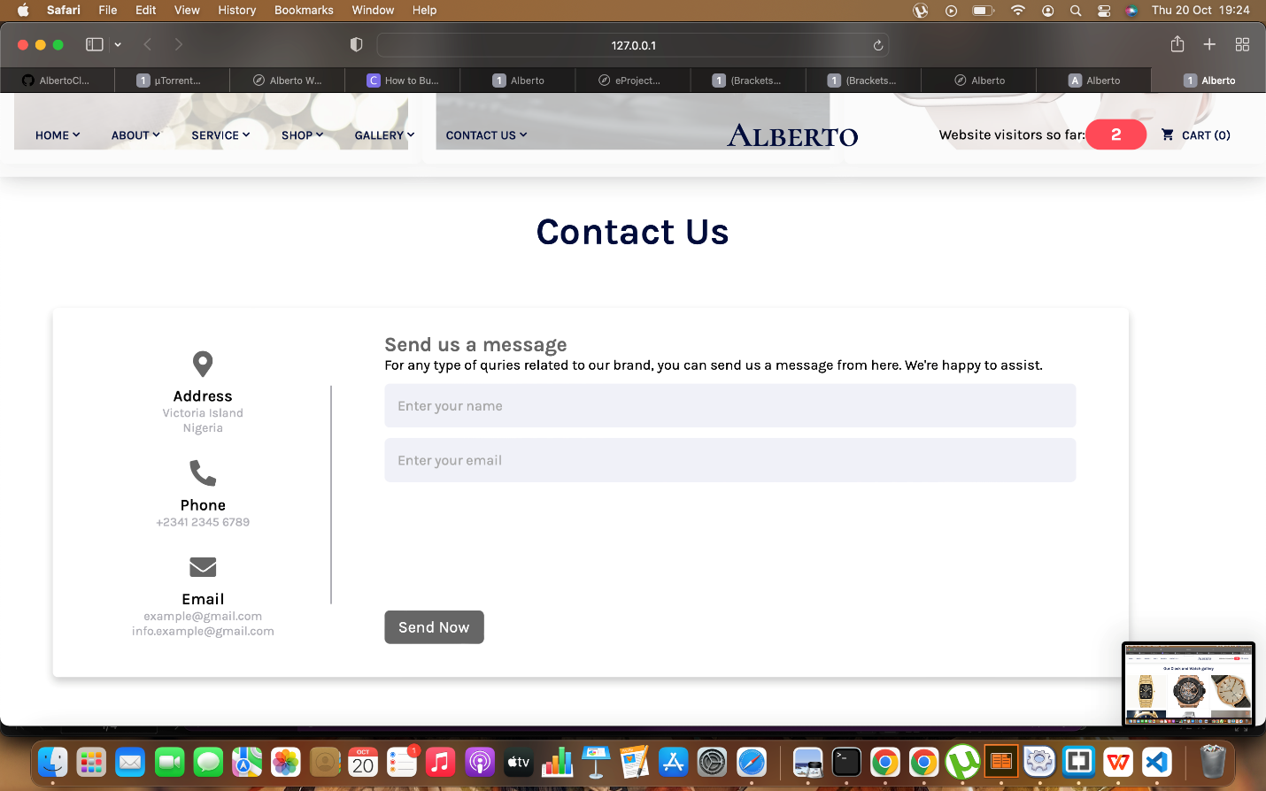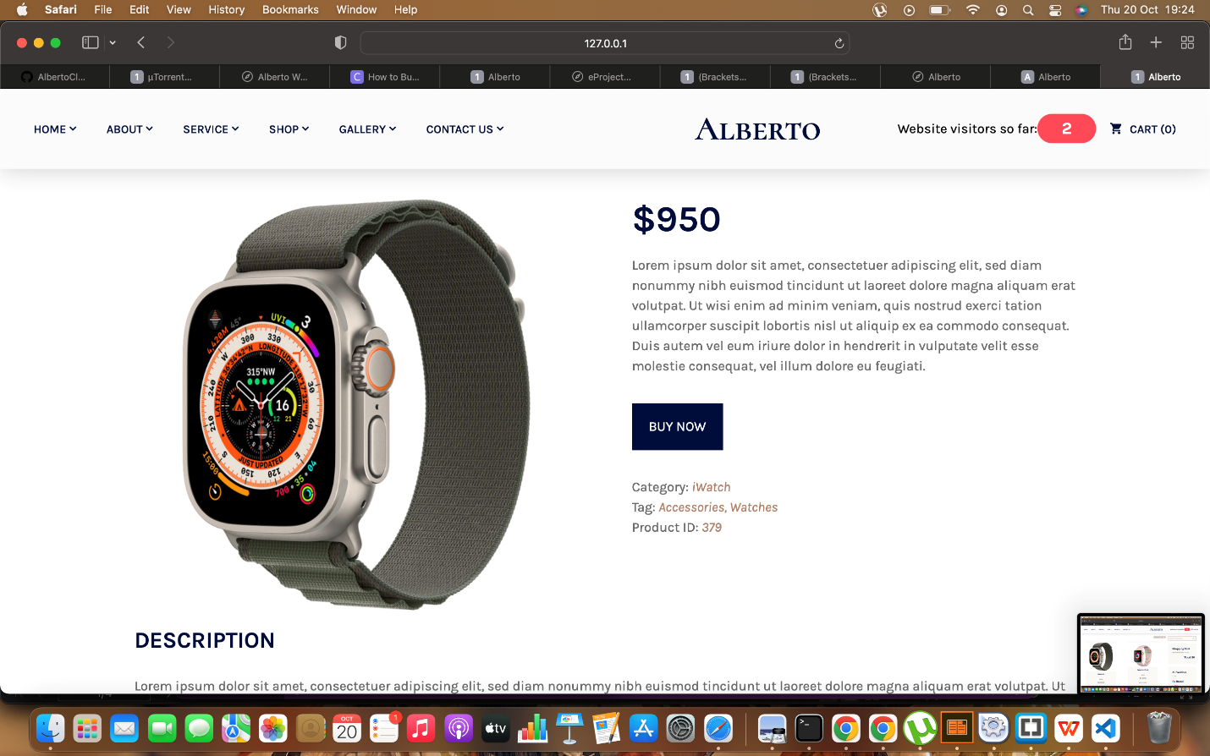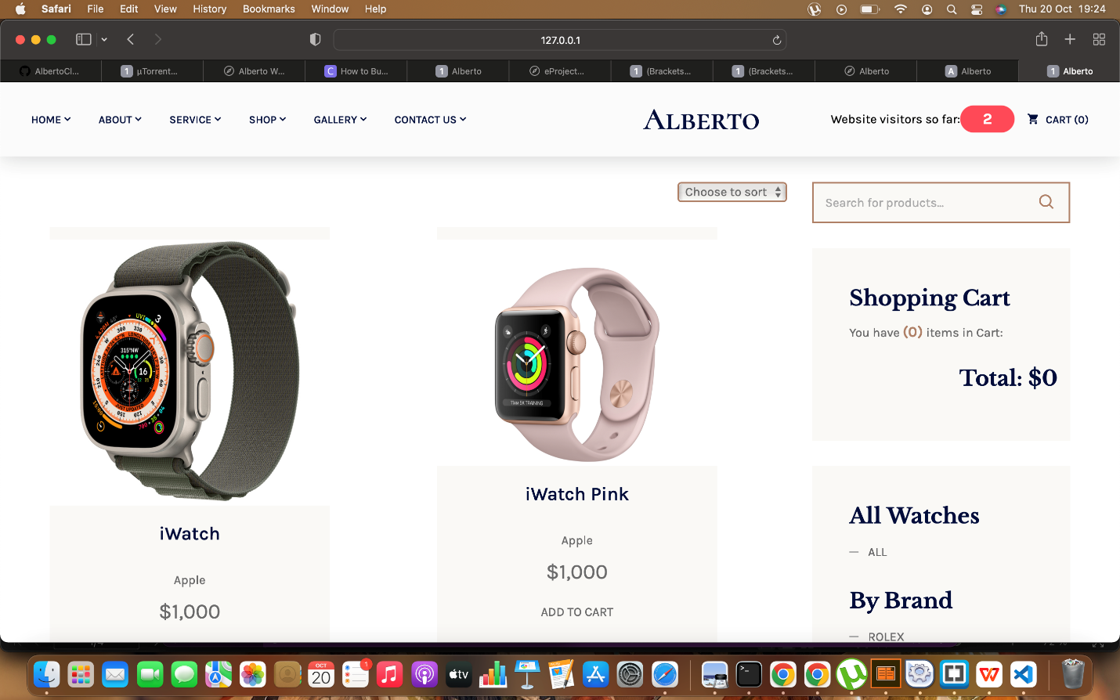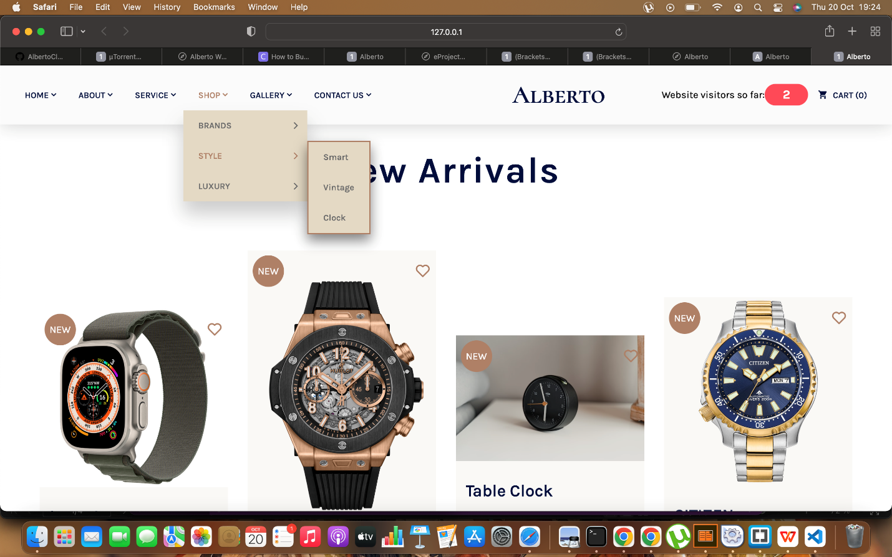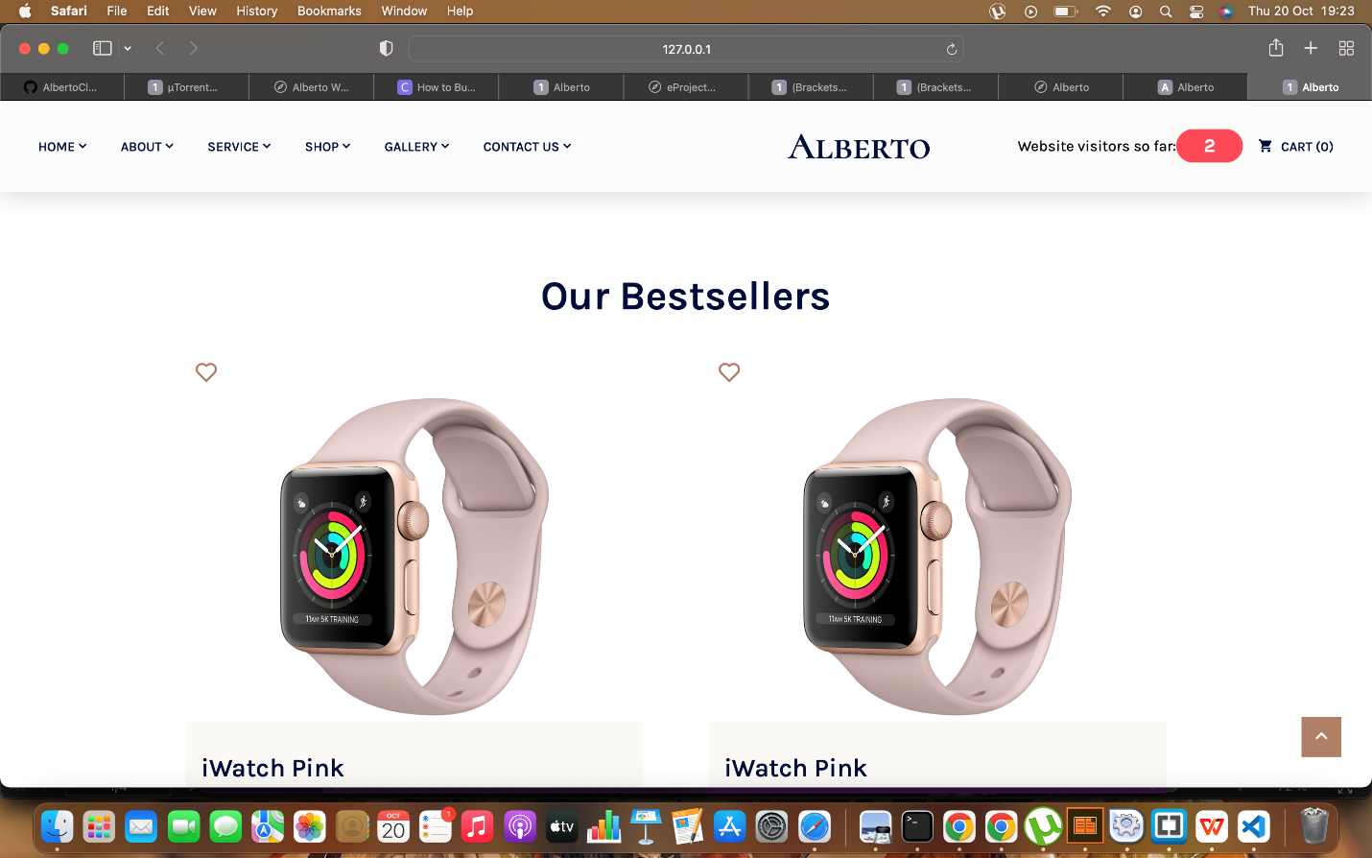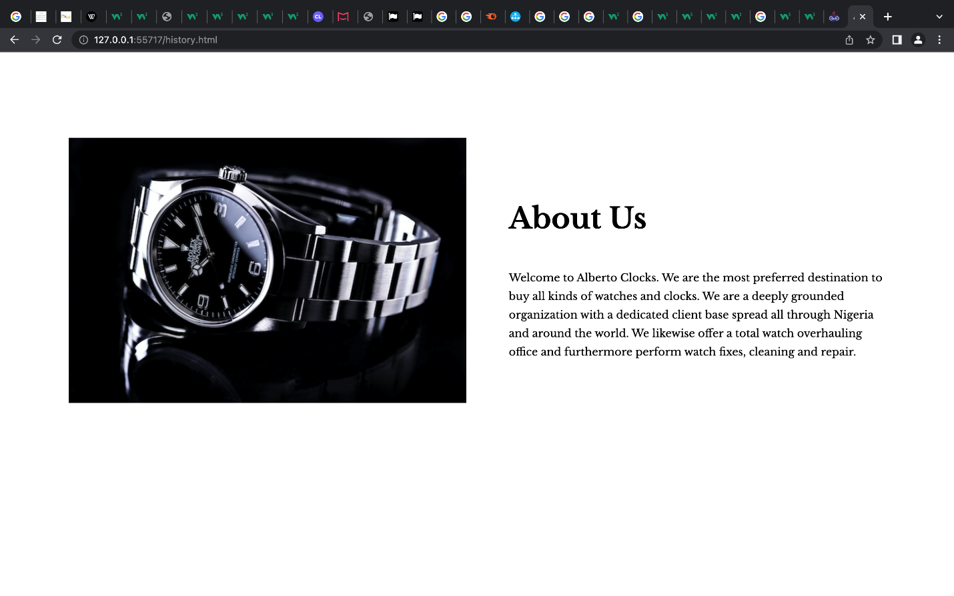

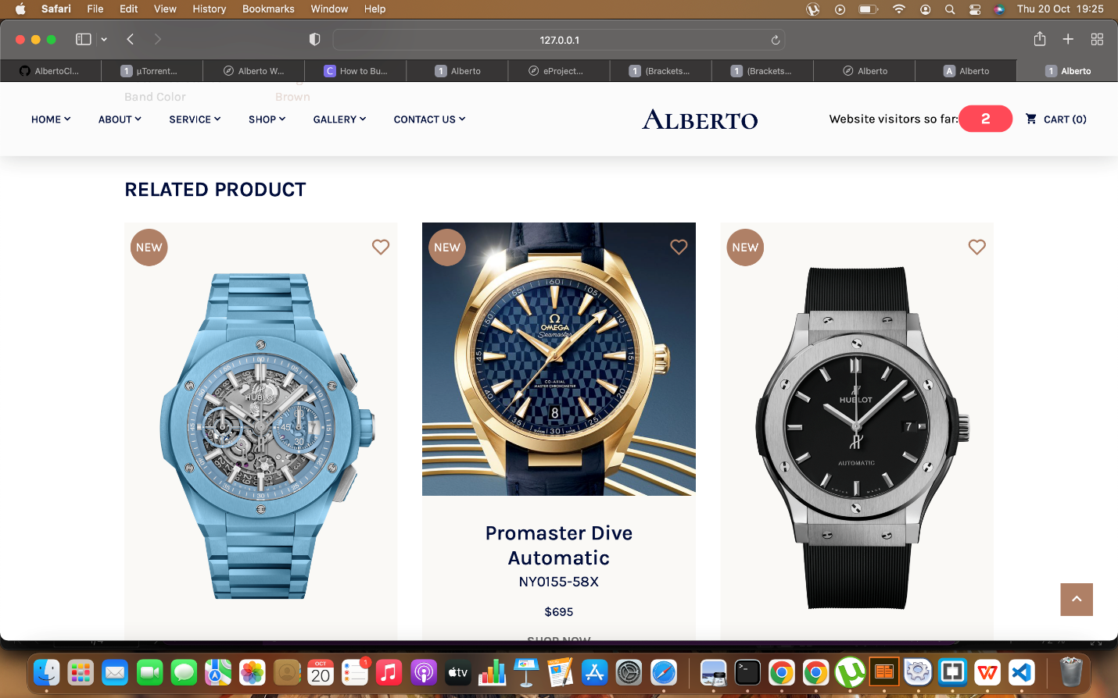

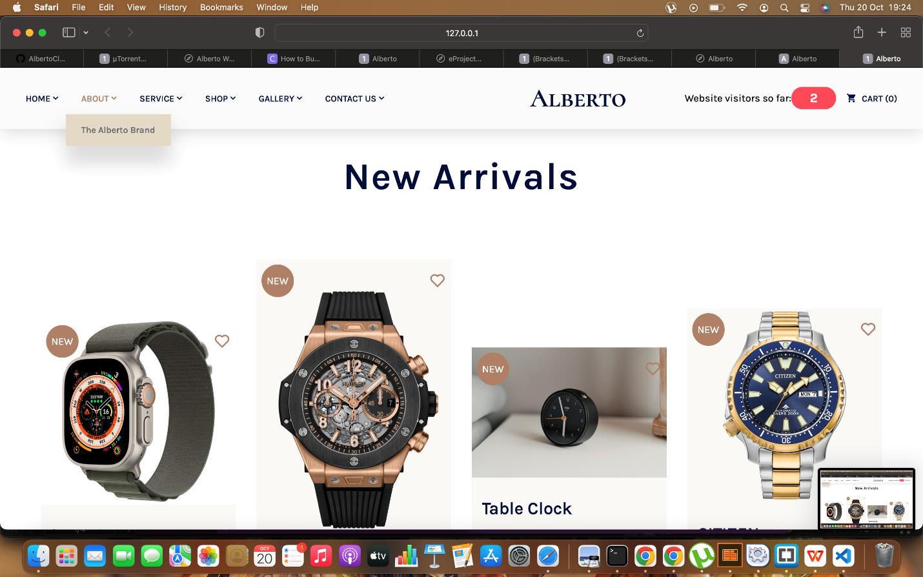

Acknowledgement

Our sincere thanks and appreciations goes to God Almighty who has been our strength and fortress.

Our great appreciation also goes to our Faculty Instructor Mr.Frank towards the success of this project, May God bless him abundantly.

To all the staff and management of Aptech Computer Education VI, Lagos, Nigeria. We are grateful for your support and assistance.